**GDC GUMMALAKSHMIPURAM**

**Report on Science Day**

**All science day department of govt degree college G.L puram planned to conduct National science day on 28th Feb, 2024. The theme of the year 2024 is indigenous technology for viksit Bharat . The day was organized with a great pleasure. Dr. S. Sobharani gaur R.J.D. CE – RJY attended as a chief guest.**

**President of the programme Dr. T. Sreevaram addressed on the significance of the day. Respected RJDCE Dr. S. Sobharani madam encouraged and motivated students to take up challenges and put efforts to achieve excellence in their life.**

**On this occasion the science departments conducted essay writing and quiz competitions. 60 to 80 students participated in the competitions. Students displayed Posters, working models and science photographs /charts showing their creative ideas and knowledge.**

**Prizes were distributed by the principal madam, RJD madam and A.O of RJD office RJY to the students.**

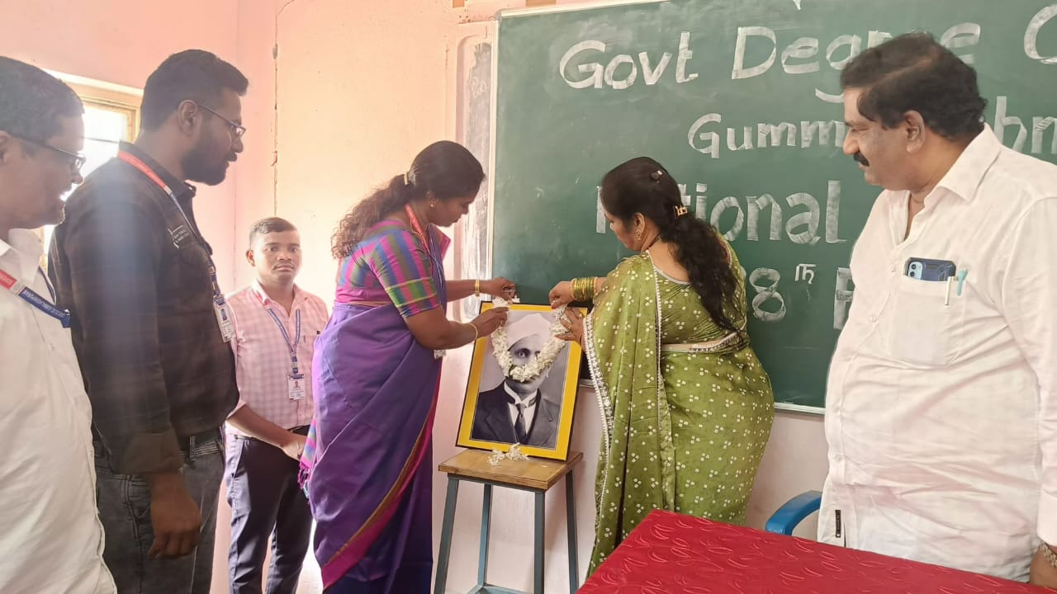

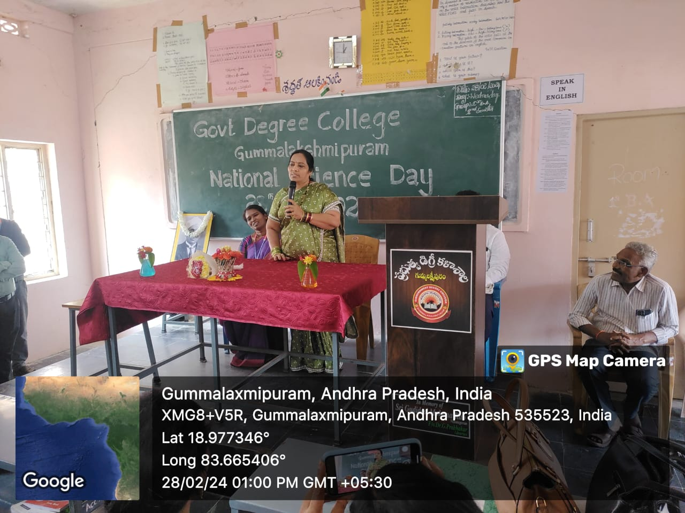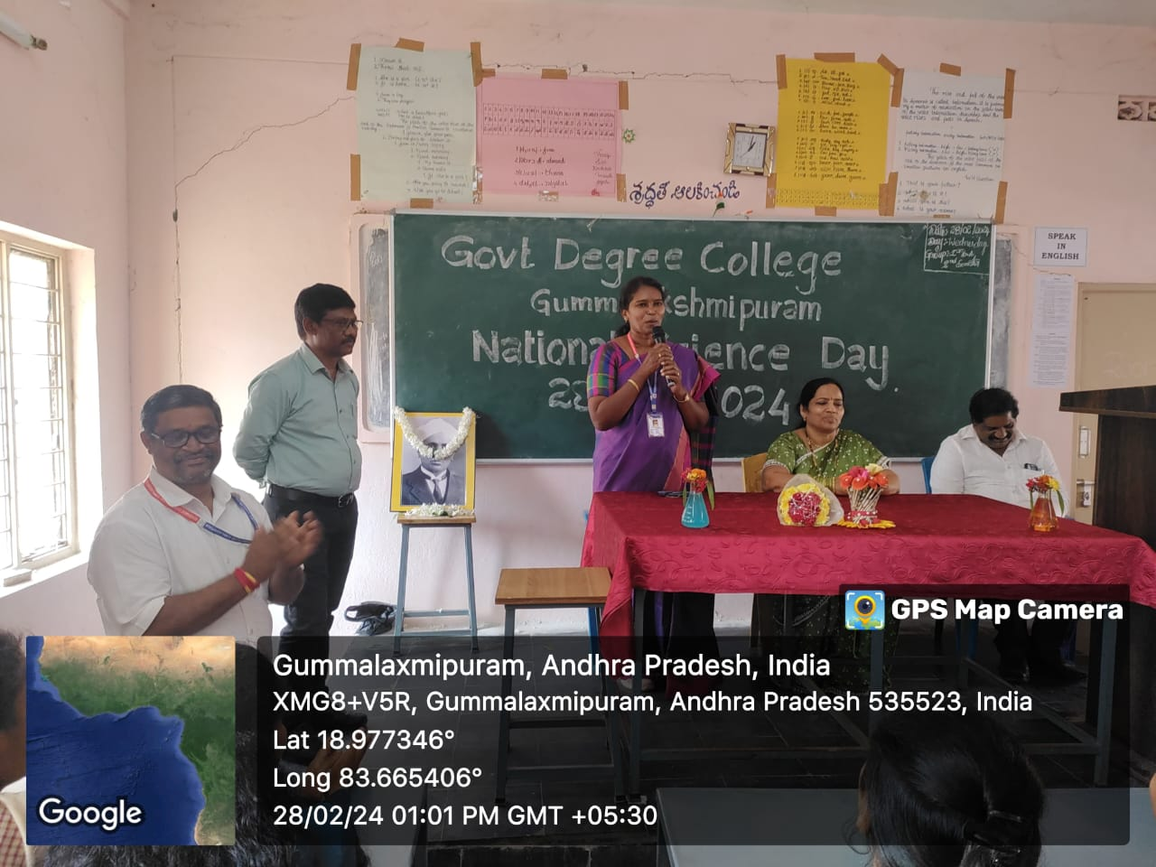

**Speech given by Dr. T. Sreevaram (Principal)**

**STUDENTS PROJECTS EXHIBITIONS**

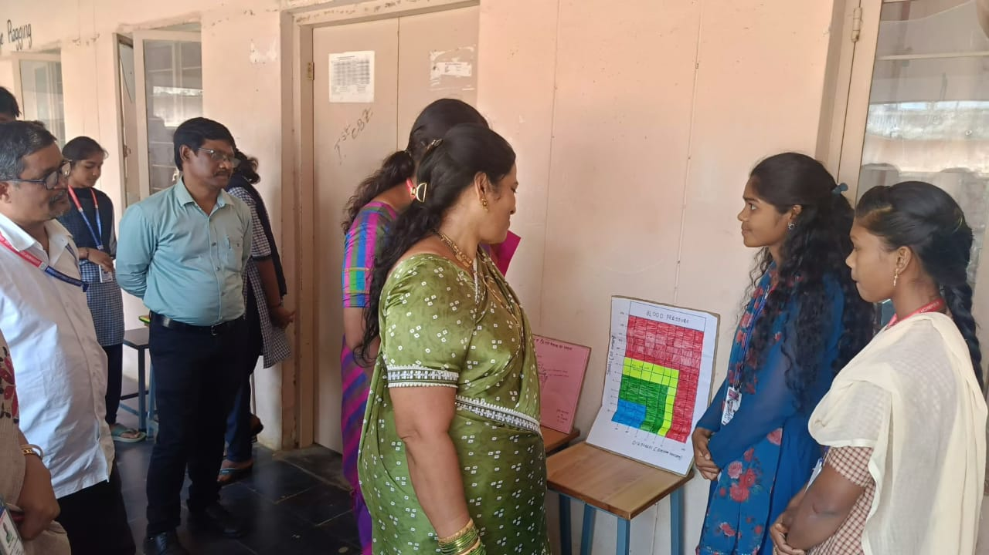

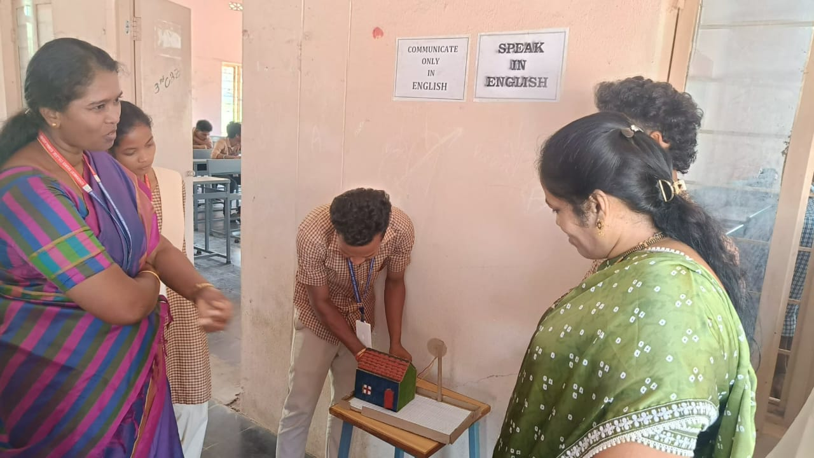

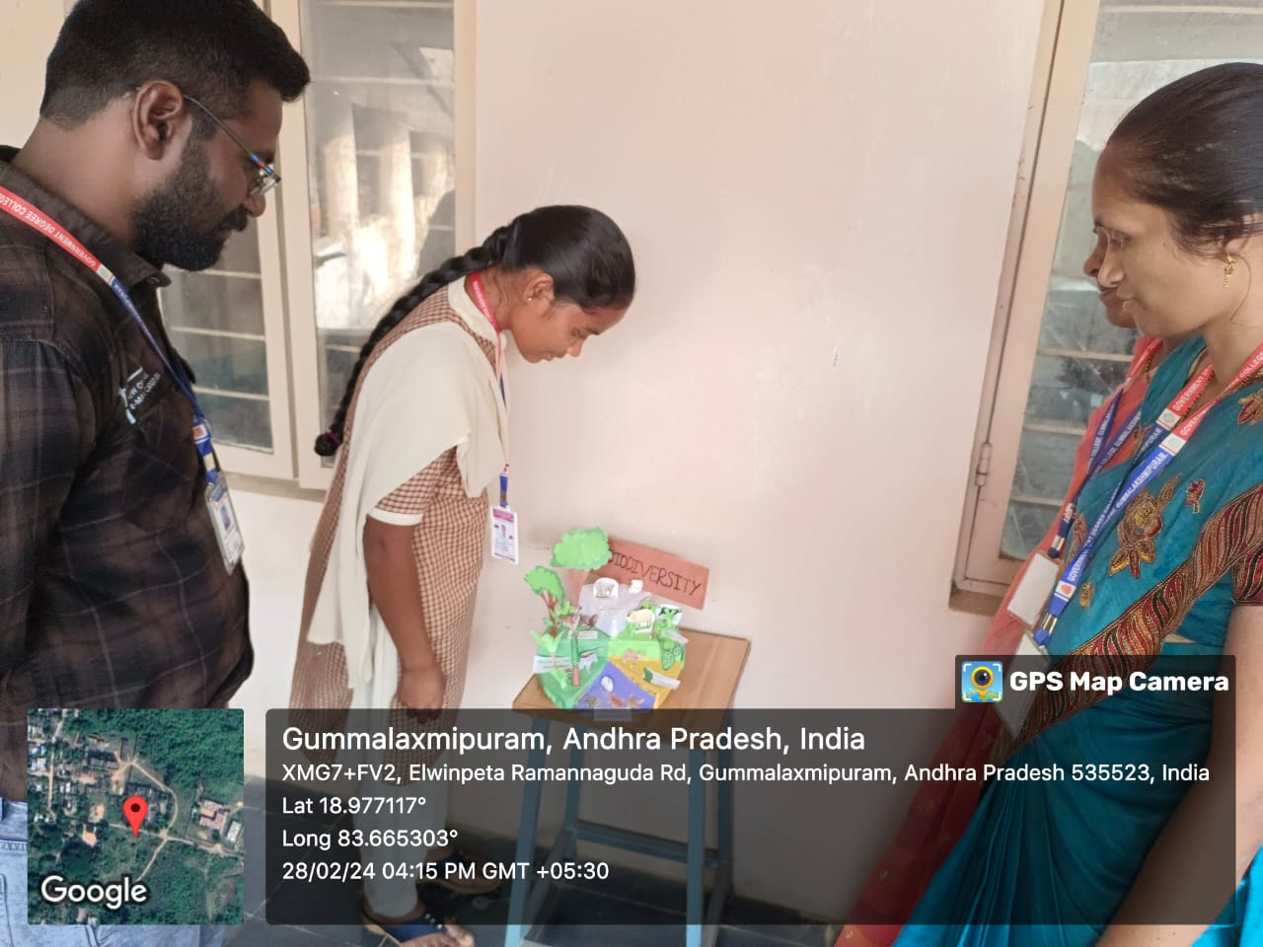

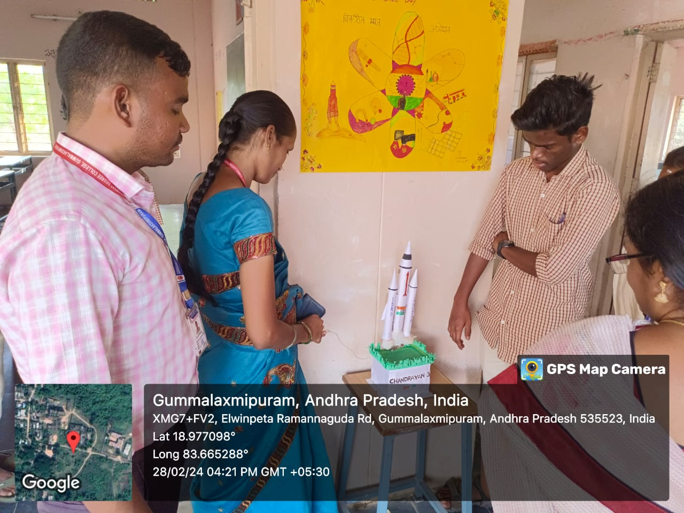

**Prizes Distribution**

